**1. Exercise :** *6* **2. Date :** *12th November, 2020*

**3. Title :** Combinations of solids: CSG and advanced solid modelling.

**4. Aim :** To model simple combinations of solids by Constructive Solid Geometry (CSG), and some advanced models using sweep, loft, shell solid models and obtain their projections.

**5. Software used :** *Autodesk AutoCAD 2021.*

**6. Introduction :**

**Constructive solid geometry, Advanced solid modelling:**

*Constructive solid geometry is a technique used in solid modeling. Constructive solid geometry allows a modeler to create a complex surface or object by using Boolean operators to combine simpler objects, potentially generating visually complex objects by combining a few primitive ones.*

*Advanced solid modeling (or modelling) is a consistent set of principles for mathematical and computer modeling of three-dimensional solids. Solid modeling is distinguished from related areas of geometric modeling and computer graphics by its emphasis on physical fidelity.[1] Together, the principles of geometric and solid modeling form the foundation of 3D-computer-aided design and in general support the creation, exchange, visualization, animation, interrogation, and annotation of digital models of physical objects.*

*…………………………………………………………………………………………………………………………………………*

6.2 CSG sketch: 6.2 Real time example - Picture

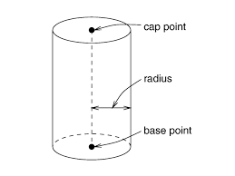

**Fig. Fig.**

**7. Procedure** (for solving question):

**7.1** Question Outline : *To understand how the objects are drawn using complex*

*conditions.*

**7.2** Object : *Cylinder, Cone, Pyramid & Sphere.*

**7.3** Resting on Conditions : *Look whether the solid is resting on V.P. or H.P.*

**7.4** Other resting Conditions (if any) :*Also, see the inclinations of solid with respect*

*to the axis.*

**7.5** Other Conditions (if any) :*All dimensions should be in millimeters (mm).*

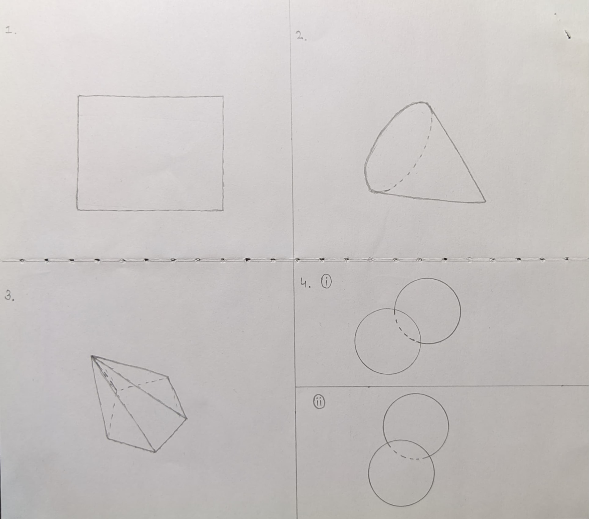

**Fig.: Free hand sketch of the solution to question**

**7.6** Drawing Procedure :

**Step 1.** ***Setting up the workspace :-***

* 1. *Set the units and precision we are going to work with using* ***“UNITS”*** *command, here we will keep precision to be 1unit place (0) and unit as millimeter.*
  2. *Then, set the workable area using* ***“LIMITS”*** *command to area of (297mm) x (210mm) by specifying origin or lower left corner as (0, 0) and upper right corner as (297, 210).*
  3. *Finally, use the command* ***“ZOOM”*** *with the* ***“all”*** *attribute to expand the work area to the entire screen.*
  4. *From the* ***“workspace switching”*** *menu, available at bottom right corner, choose the* ***“3D Modelling workspace”*** *to draw the solids as instructed. Also, prefer using the different views so it will be easy to construct the solid (available in top left corner of the window).*
  5. *Also select* ***“First angle Projection”*** *available in the* ***View*** *menu in the* ***RIBBON.***
  6. *Use the command* ***“LINE”*** *to make XY axis.*

**Step 2. *Drawing a Cylinder :-***

* 1. *Using the* ***“CYLINDER”*** *command make a cylinder in the top view.*
  2. *Switch the view to the “Front” view.*
  3. *Rotate the* ***“CYLINDER”*** *by $45°$ using the* ***“ROTATE”*** *command.*
  4. *Set the drafting method to First Angle Projection.*
  5. *View base from model space.*
  6. *Plot the front, top and side views on the Layout.*

**Step 3. *Drawing a Cone :-***

* 1. *Select the* ***FRONT*** *view from the view menu.*
  2. *Use the command* ***“CONE”*** *to start drawing a cone of required conditions as given base diameter of cone is 40mm.*
  3. *By switching into the views mentioned in point (setting up workspace) move to the* ***FRONT*** *view & extrude the entire cone using* ***“EXTRUDE”*** *command up to 45 mm as it is the altitude.*
  4. *Now, move from* ***2D-WIREFRAME*** *view to* ***CONCEPTUAL*** *view as it gives actual appearance of the solid.*
  5. *Click on* ***VIEW*** *available in* ***RIBBON*** *& select option Model Space then select the object to be redirected.*
  6. *Using this option, AUTOCAD redirects to the Layout page where one can project solids in top, front, side views respectively.*
  7. *Using the* ***“TEXT”*** *command, name the necessary terms if required (i.e. Front view, Top view, Side view, etc.).*
  8. *Measure the sides of the Circle (Top view), Triangle (Front & Side view) using the* ***“DIMENSION”*** *command.*
  9. *Also,* ***“DIMSTYLE”*** *command can be used to set the size of arrows & text of dimensions.*

**Step 4.*****Drawing a Pentagonal Pyramid :-***

* 1. *Using the* ***“PYRAMID”*** *command make a pyramid in the TOP view with edge as 25 and height as 60 mm.*
  2. *With the edge of the pyramid draw a line 20mm perpendicular and another line parallel to the base of the pyramid using the* ***“LINE”*** *command.*
  3. *Cut an arc on the pyramid, with the base of the pyramid as radius*
  4. *Using the* ***“ROTATE”*** *command rotate the pyramid to the intersection point of the arc and the pyramid.*
  5. *Set the drafting method to* ***First Angle Projection.***
  6. *View base from model space.*
  7. *Plot the front, top and the side of the pyramid on the layout.*

**Step 5.** ***Drawing Sphere :-***

* **Touching Spheres, line joining centers parallel to wall and floor.**
  1. *Use the command* ***“SPHERE”*** *to draw identical spheres of diameter 30 mm, touching each other.*
  2. *Generate Base View using the command* ***“VIEWBASE”*** *in a blank layout.*
* **Touching Spheres, line joining centers inclined to wall and parallel to floor.**
  1. *Use the command* ***“SPHERE”*** *to draw identical spheres of diameter 30 mm, touching each other.*
  2. *use the command* ***“ROTATE”*** *to rotate the sphere at an angle 30° to the wall.*
  3. *Generate Base View using the command* ***“VIEWBASE”*** *in a blank layout.*

**Step 6.*****Annotations :-***

* 1. *Using the command* ***“DIM”*** *and appropriate attributes mark all the dimensions taken in the experiment.*



**8. Commands Used :**

|  |  |  |
| --- | --- | --- |
| *Sr. No.* | *Command* | *Use* |
| ***1.*** | *UNITS* | *Used to set unit type and precision.* |
| ***2.*** | *LIMITS* | *Define the workspace and give it a boundary.* |
| ***3.*** | *ZOOM* | *Expand/contract the work area to the visible screen.* |
| ***4.*** | *LINE* | *Used to draw lines.* |
| ***5.*** | *DIMSTYLE* | *Used change the look of the dimensions.* |
| ***6.*** | *STYLE* | *Used to change the way the text looks.* |
| ***7.*** | *TEXT* | *To write text in the Autocad file.* |
| ***8.*** | *CYLINDER* | *Draw a cylinder.* |
| ***9.*** | *CONE* | *Draw a Cone.* |
| ***10.*** | *SPHERE* | *Draw a sphere.* |
| ***11.*** | *PYRAMID* | *Draw a pyramid with n sided polygonal base.* |
| ***12.*** | *VIEWBASE* | *Draw orthographic projection view from 3D model.* |
| ***13.*** | *ROTATE* | *Rotate the selected object by any angle.* |
| ***14.*** | *DIM* | *Used to write the dimension of the objects.* |

**9. Result :**

*Thus, by the use of AutoCAD 2021 we are able to draw the solids respective of given length and also according to given inclinations. True length & Projected length can also be determined.*

|  |  |  |  |
| --- | --- | --- | --- |
| **Faculty Name** |  | **Date of Submission** |  |
| **Signature** |  | **Marks** |  |